**Jira Fundamentals:**

Jira Project:

A **Jira Project** is a **workspace** where all related work is tracked.

If Jira is a **building.**  
 Project is a **room**.  
Issues are the **items inside the room**.

* Project contains issues, workflows, boards, and reports

Types of JIRA Projects:

Jira has **TWO MAIN PROJECT TYPES**:

1️⃣ **Team-Managed Project**  
2️⃣ **Company-Managed Project**

What is a Team-Managed Project?

A **Team-Managed Project** is a project where:

* **The team controls everything**
* No dependency on Jira Admin

**When to use:**

* Small teams
* New Jira users
* Short-term projects
* Internships / practice

Steps to create Team-Managed Project:

1. Click **Projects → Create project**
2. Select **Scrum** or **Kanban**
3. Choose **Team-managed**
4. Enter Project Name & Key
5. Click **Create**

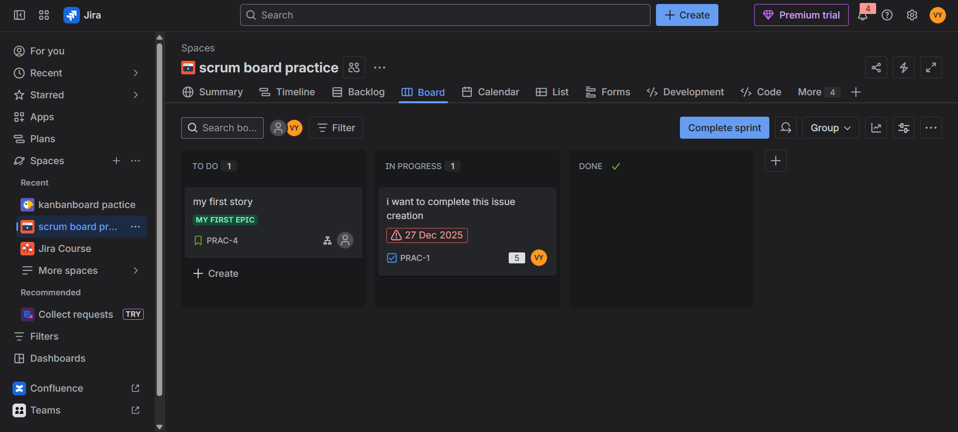

* Team-managed projects are self-contained and allow teams to manage workflows and issue types without admin involvement.

What is a Company-Managed Project?

A **Company-Managed Project** is centrally managed by:

* Jira Admin
* Organization standards

**When to use:**

* Enterprise projects
* Multiple teams
* Long-term products
* Strict processes

Steps to create Company-Managed Project

1. Click **Projects → Create project**
2. Select **Scrum / Kanban**
3. Choose **Company-managed**
4. Enter project details
5. Create project

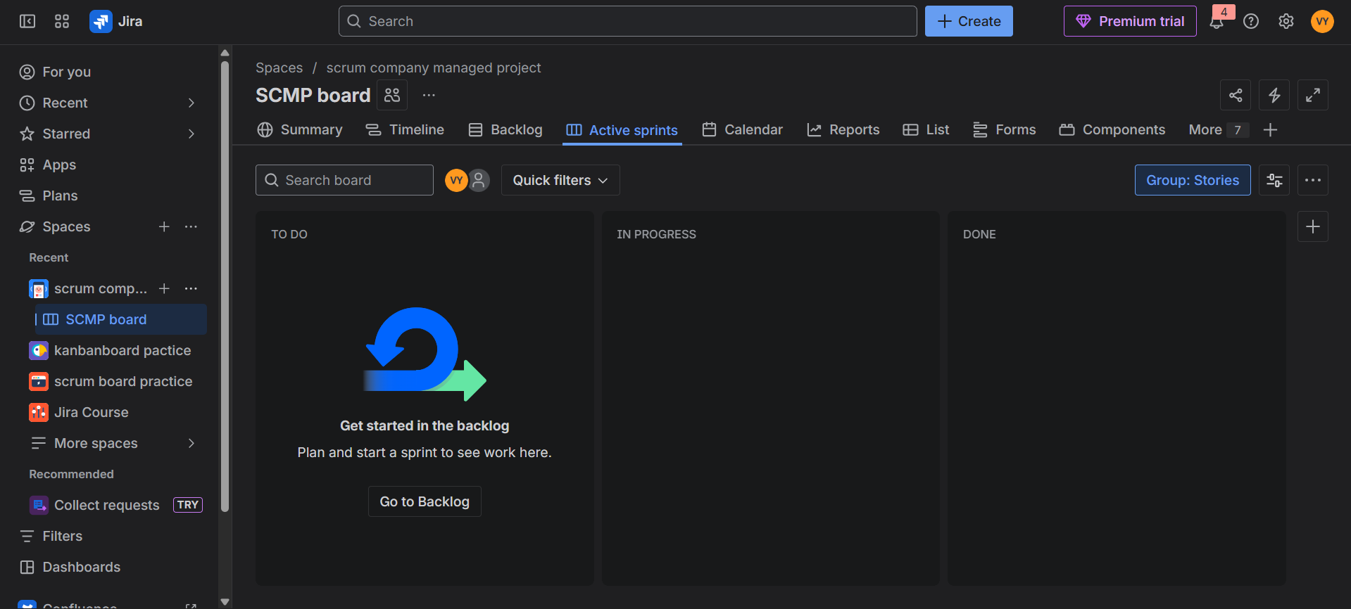

* Company-managed projects use centralized schemes and are ideal for maintaining consistency across multiple teams.

**Jira Issue Types:**

Issue types define the nature of work being tracked in Jira, such as bugs, tasks, or user stories.

Issue types help Jira to:

* Apply correct **workflow**
* Enable proper **reporting**
* Maintain **work hierarchy**
* Differentiate bugs from features

Without issue types, everything would be just a task — **no structure**.

**Epic**

An **Epic** is a **large feature** broken into smaller stories.

Example:

* Epic: User Management
  + Story: User Login
  + Story: User Registration

**Hands-On (How to create an Epic):**

1. Click **Create**
2. Select **Issue Type → Epic**
3. Give Epic Name
4. Add description
5. Create

**Story**

A Story represents a user requirement.

**Format:**

**As a user,I want ___ so that ___**

Example:

As a user,I want to reset my password so that I can regain progress.

**Hands-On:**

1. Click **Create**
2. Issue Type → **Story**
3. Write story summary & description
4. Assign to Epic (optional)
5. Create

**Task**

A **Task** is a unit of work that **does not represent a user requirement**.

**Hands-On:**

1. Create issue
2. Select **Task**
3. Add details
4. Assign user

**Bug**

A **Bug** is an issue raised when the system behaves **incorrectly** or **unexpectedly**.

**Hands-On:**

1. Create issue
2. Select **Bug**
3. Add steps to reproduce
4. Set priority
5. Assign developer

Bug Lifecycle

Open → In Progress → Testing → Done

**Subtask**

A Sub-task is a small piece of work under a Story or Task.

**Hands-On:**

1. Open Story / Task
2. Click **Create Sub-task**
3. Add sub-task details
4. Assign user

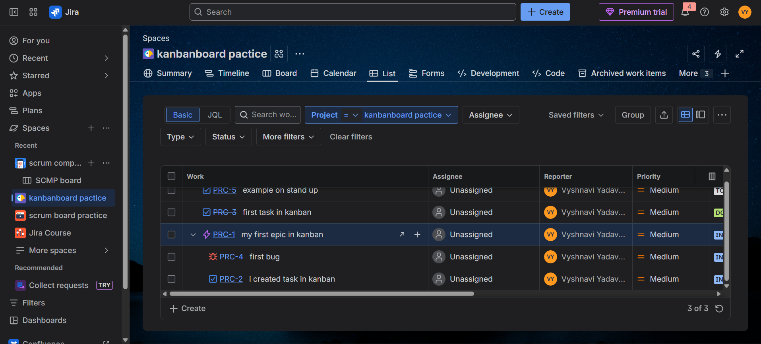

Issue Heirarchy:

Default Jira Hierarchy:

**Epic**

**└── Story / Task / Bug**

**└── Sub-task**

EPIC LINKING

* Stories/Tasks are **linked to an Epic**
* Epic tracks overall progress

**Hands-on:**

* Open Story
* Set **Epic Link** field

Epic links help track progress of large features across multiple sprints.

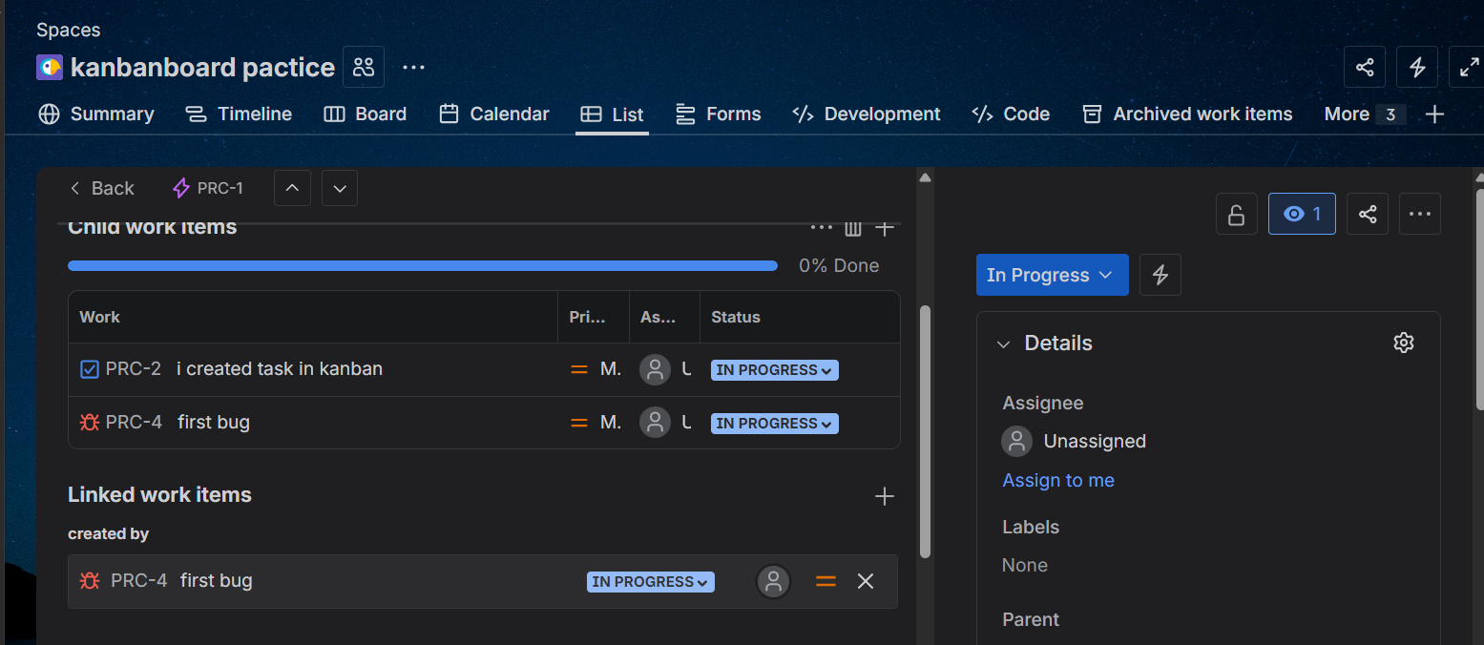

**Working with Kanban and Scrum Boards in Jira**

**Board**

A **Board** is a visual way to track work.

Types of boards:

* **Scrum Board**
* **Kanban Board**

**Scrum**

**Scrum** is an Agile framework used for development.

Key Scrum terms:

* Sprint
* Backlog
* Sprint Planning
* Daily Stand-up

Used when work is planned in time-boxed iterations.

**HANDS-ON: Scrum Board in Jira**

**Step-by-Step:**

1. Create Scrum Project
2. Open Backlog
3. Add stories/tasks
4. Create Sprint
5. Drag issues into sprint
6. Click Start Sprint

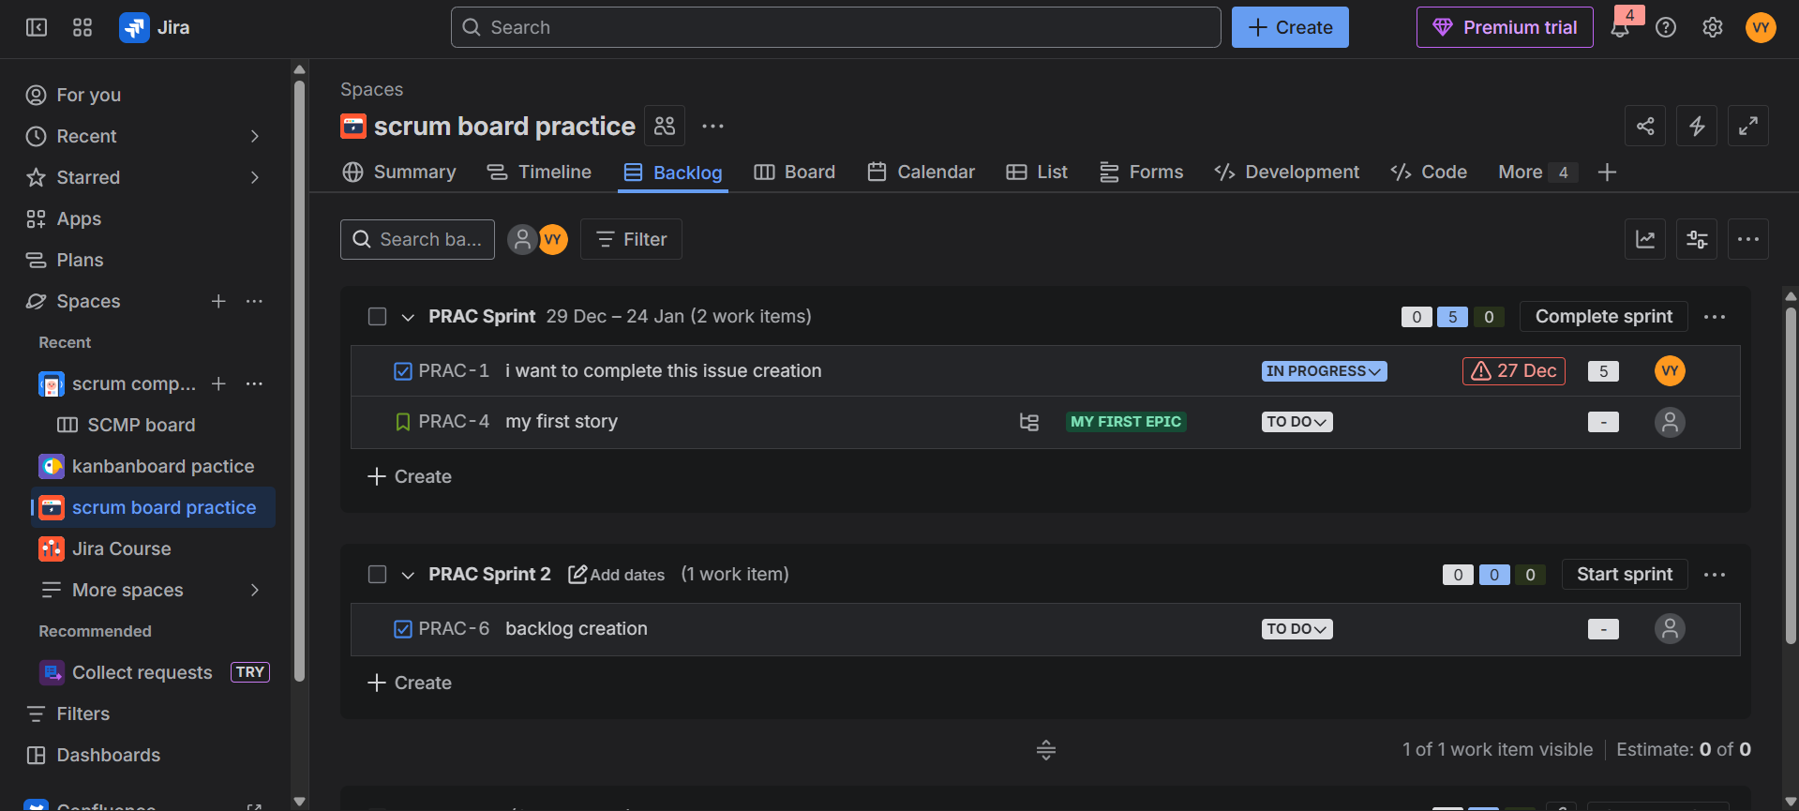

**Kanban**

**Kanban** is an Agile method focused on **continuous delivery**.

Key features:

* No fixed sprint
* Continuous workflow
* Work-in-progress (WIP) limits

**HANDS-ON: Kanban Board in Jira**

**Step-by-Step:**

1. Create **Kanban Project**
2. Add issues directly to board
3. Move issues across statuses
4. Apply WIP limits (if allowed)

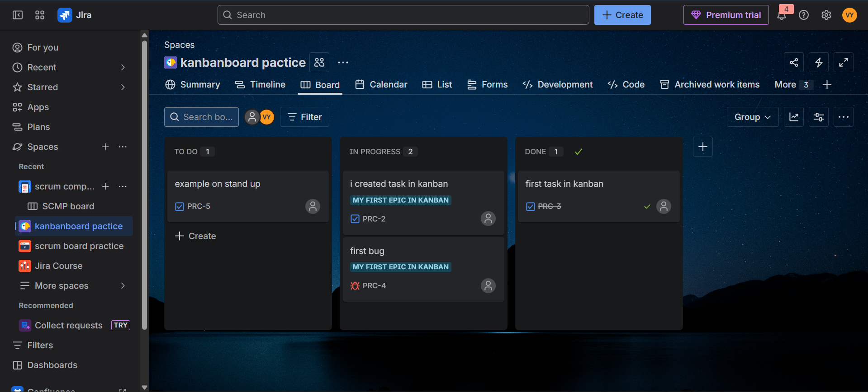

**Views**

Views are different screens/pages in Jira that help you:

* Plan work
* Execute work
* Inspect work details

In Jira, the three most important views are:  
Backlog View  
 Board View  
 Detail View

Together, they cover the entire Agile lifecycle.

Backlog, Board, and Detail views represent planning, execution, and inspection of work in Jira.

**Backlog View**

The **Backlog View** shows a **prioritized list of all pending work** that is not yet completed.

It is mainly used in **Scrum projects**.

**What you see in Backlog:**

* Epics
* Stories
* Tasks
* Bugs
* Sprints (future & active)

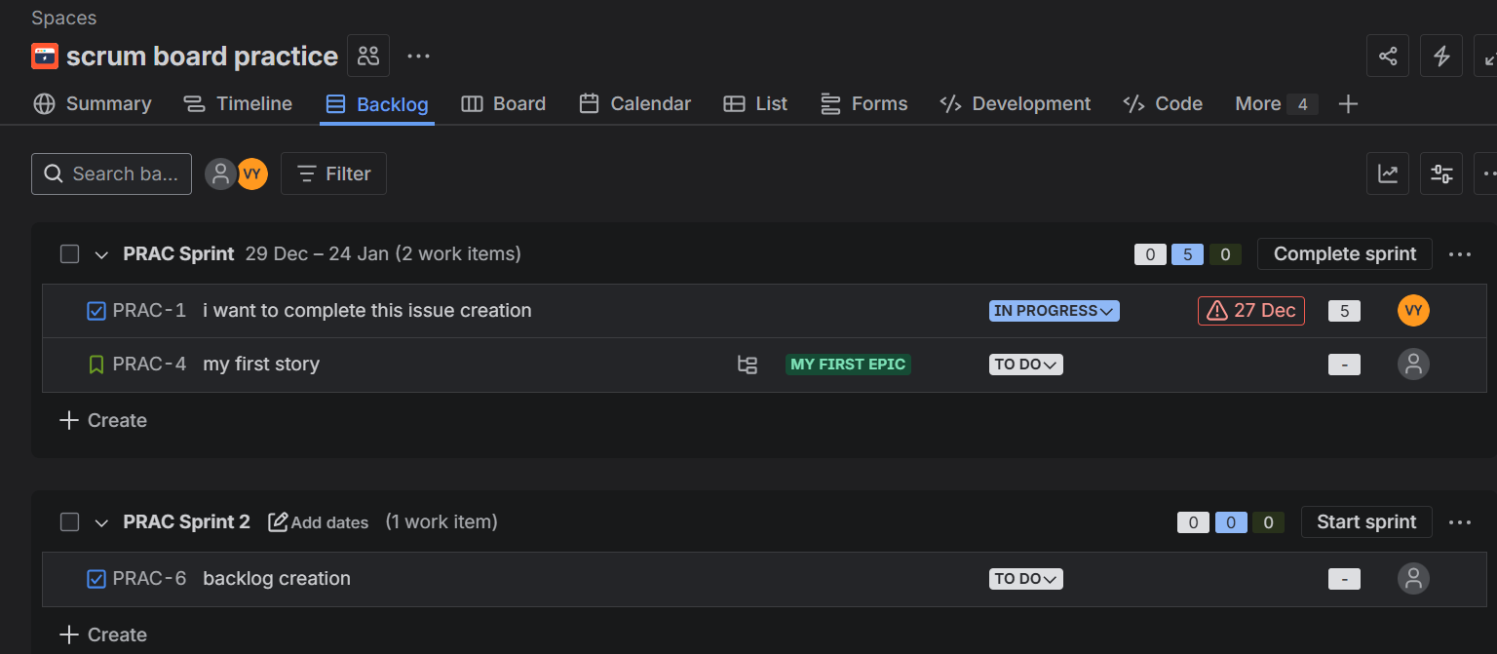

Board View

The **Board View** shows **active work** arranged by **workflow statuses**.

**What you see on the Board:**

* Columns (To Do, In Progress, Done)
* Issues as cards
* Swimlanes (if enabled)
* Assignees, priority, etc.

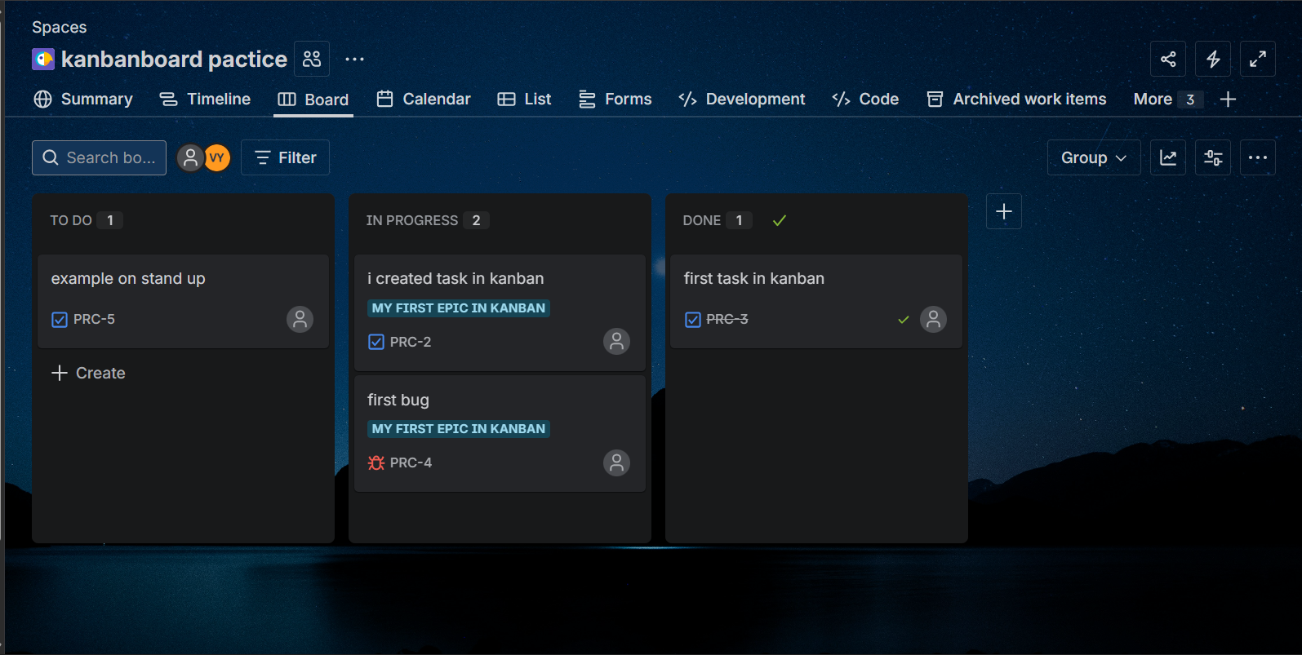

Detail View

The **Detail View** shows **complete information about a single issue**.

**What you see in Detail View:**

* Summary
* Description
* Status
* Assignee
* Comments
* Attachments
* Sub-tasks

